
BRD
Shark Tank Platform

May 31, 2025
Product management team

Document Release History

# | Version | Issue Date | Author | Comments
1 | v 1.00 | 31/05/2025 | Mohamed Ali | Initial publication
2 | V1.01 | 2/06/2025 | Mohamed Ali | - Update user story #005  - Update figure #3

Reviewers

# | Name | Role
1 |  | Product Manager Lead

Contents
1. General Notes: 3
2. Introduction: 4
• Background 4
• Goals 4
• Intended Audience 4
• Document Scope 4
• Product Scope 4
• Out of Scope 4
3. Assumptions: 5
4. Limitations: 5
5. SWOT Analysis: 5
6. Key Matrix: 6
7. MVP Feature List: 6
8. Product Roadmap: 7
9. Success Metrics: 7
10. Business Model: 7
11. User Story Diagram: 8
12. User Story Cards: 9
12.1. Founder submit a start-up request 9
12.2. Admin approves the start-up request 10
12.3. Investor views the start-up list 11
12.4. Investor reviews a specific start-up request 12
12.5. Investor use advanced search to get a short list of active stat-ups 13
13. Wireframes: 14
13.1. Founder Landing Page 14
13.2. Investor Landing Page 15
13.3. Admin Start-ups List 16

General Notes:

- All business rules must be presented as a guide for data entry in each field (tooltip or hint). These should be displayed when hovering over the data field with the mouse.

- When opening any lookup list, the ability to search for a specific option by typing part of its name must be enabled, so that options containing the entered text are retrieved (autocomplete).

- An “All” option must be available in any lookup list that allows the selection of one or more items.

- When pressing certain buttons or links, the system must validate that all mandatory fields are filled in and that all data has been entered correctly. If not, warning messages should be displayed as specified in the table next to each data field.

Validation
  Message
Missing entry in a mandatory field | Data entry is required in this field.
Incorrect data entry in violation of business rules | Please re-enter the data correctly according to the defined business rules.

Introduction:

Background
Currently, the start-up is facing a huge challenge to reach the suitable investor to raise his start up value and money.

Goals
Sark Tank platform builds an application to link between start-ups and investors to share the start-ups opportunities with investors and to let the start-ups check the investors.

Intended Audience
The document addresses all Shark Tank stakeholders, product management, financial, marketing and per-sales departments.

Document Scope
- Wireframes
- User story Cards
- User Story Diagram

- Personas & Characteristic
- Founder: Seeking visibility and capital for their venture.
- Investor: Looking for curated start up opportunities.
- Admin: Manages operations, content, and analytics.

Product Scope
- Web Portal (Admin)
- Website (Founder & Investor)
- Mobile App (Founder & Investor)

Out of Scope
Third-party developed APIs:
- SMS Provider
- Email Service Provider
- Payment Gateway
- Facial Recognition Identity Verification

Assumptions:

  - Founders and investors will be willing to share profile information securely.
  - The platform will comply with global data privacy regulations (e.g., GDPR).
  - Founders and investors has to read and accept terms & conditions.
  - Admins has to reviews and approve founders & investors registration request.
  - Admins has to reviews and approve start-up request.

Limitations:

  - Limited availability of verifiable data from new start-ups.
  - Investor-side verification will be essential to avoid scams.
  - Platform adoption depends on marketing and trust-building.

SWOT Analysis:

  - Strengths
    - Unique matchmaking model.
    - First-mover advantage in local market.
  - Weaknesses
    - Dependent on user trust.
    - Requires strong moderation.
  - Opportunities
    - Identify investment opportunities.
    - Providing market researches & insights.
    - Providing investment consultation services.
  - Threats
    - Established competitors.
    - No legal guarantees.

Key Matrix:

Metric
  Why It’s Important
Active users (Founders/Investors) | Measure engagement and growth
Concluded deals rate
  Measure platform value
Average response time | Track user satisfaction
Investor interest (clicks/views on Founder profiles) | Understand demand
Retention rate | Assess long-term usability

MVP Feature List:

# | Feature | Admin Portal | User Portal
# | Feature | Admin | Founder | Investor
 | Registration | ×
 | Login
 | User Role |  | × | ×
 | Landing Page
 | Profile | ×
 | Admin Panel |  | × | ×
 | Manage Start-up | × |  | ×
 | Start-up list & Advanced search
 | Online Meeting | ×
 | Notification
 | Basic analytics dashboard
Total Features |  | 7 | 9 | 8

Product Roadmap:

  - The backlog will be under updates through the product time line.
  - The perfect environment to deploy MVPs is scrum/Agile.
  - Weekly sprint planning and retrospectives
  - Daily stand-ups
  - Stakeholder demos at the end of sprint.
  - Sprint customs as (15 days).
  - Product management & task assignment tool is Azure DevOps.
  - Team mate are 11 persons (product owner, business analyst, UI/UX designer, 2 front end, 2 backend, 2 tester, DevOps Specialist, and scrum master).
  - Total Features are 24.
  - Every Feature includes 4 user story as average.
  - User story priority based on needs, dependence and DOR.
  - Assume a same complexity for all user stories.
  - Story point is Middle (9)
  - Total user stories (96) item.
  - Expected bugs (40) item.
  - Expected Technical issue (15) item.
  - Expected Business issue (15) item.
  - Sprint velocity (280) story point.
  - MVP planned to deploy in (6) sprints.

Success Metrics:

  - 10% of start-ups get matched with investors monthly
  - 80% user retention after 3 months
  - Time to first interaction less than 7 days

Business Model:

  - Free basic usage
  - Premium subscriptions for enhanced visibility and analytics
  - Investor subscription fees
  - Commission on successful Deals

User Story Diagram:

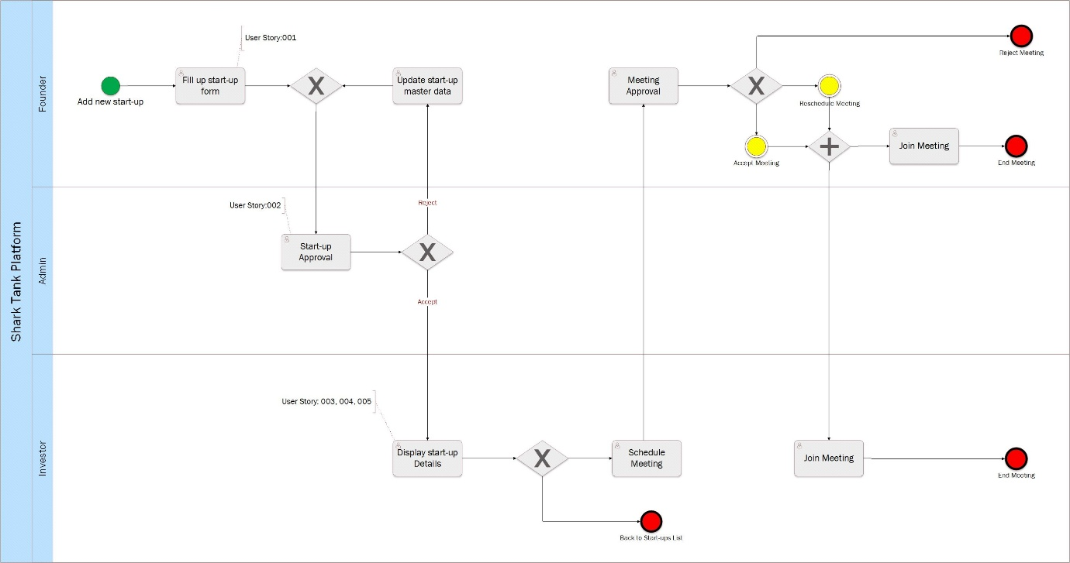

Start Event | - Add new start-up
Intermediate Event | - Reschedule meeting  - Accept meting
End Event | - Reject meeting  - End meeting  - Back to Start-ups List
Integrated app | - Online meeting (zoom, teams...etc.)

User Story Cards:

Founder submit a start-up request

001 | Founder submit a start-up request
- As a/an | - Founder
- I want to | - Submit the start-up request.
- So that | - Can get fund from the investors.
- Given | - Founder views the landing page
- When | - Founder clicks on the “start-up” buttons
- Then  - Given  - When  And  - Then | - System redirect the user to the “Start-up” form  - Founder views the Start-up form  - User fills up the “Start-up” master data  Click on the “submit” button  - System acts the following tasks:  - Validates inputs system rule, display failure message if response falls (warning message table) and successful message if response true  - Display the valid request in admin start-ups list in “pending” status  - Send internal notifications to all admins who’s assigned to this start-up category by the super admin.  - Deactivate “submit” button

Admin approves the start-up request

002 | Admin approves the start-up request
- As a/an | - Admin
- I want to | - View the new start-up requests.
- So that | - Can approve the start-up request.
- Given | - Admin views the “start-ups list”
- When | - Admin clicks on “review” button on a specific start-up request on “pending” status
- Then  - Given  - When  - When | - System redirect user to the “start-up” details in “view mode”  - Admin reviews the start-up details”  - Admin clicks on “accept/reject” button  - System acts the following tasks:  - In case Admin accepts the request  - Change the start-up status to “active” in founder, Investor and Admin “start-up list”  - Send internal notifications to all investors who’s interested in this start-up category.  - In case Admin rejects the request  - Allows admin to identify the rejection reason  - Change the start-up status to “rejected” in start-up’s founder and Admin “start-ups list”  - Send internal notifications to the start-up’s founder with the updated status  - Allows founder to view the rejection reason  - Allows founder to click “update” button” to open the “edit mode”.  - Allows founder to clicks ‘submit” button by activate it in case the start-up updated

Investor views the start-up list

003 | Investor views the start-ups list
- As a/an | - investor
- I want to | - View the start-up lists.
- So that | - Can views the available start-ups.
- Given | - Investor views the landing page
- When | - Investor clicks on “start-ups list”
- Then | - System redirect user to the “start-up list” displayed all active start-ups

Investor reviews a specific start-up request

004 | Investor reviews a specific start-up request
- As a/an | - Investor
- I want to | - Display a specific start-up details.
- So that | - Can reviews the start-up details.
- Given | - Investor display the start-ups list
- When | - Investor clicks on “review” button on a specific start-up request on “active” status
- Then | - System redirect user to the “start-up” details in “view mode” and allows user to back to start-ups list

Investor use advanced search to get a short list of active stat-ups

005 | Investor use advanced search to get a short list of active stat-ups
- As a/an | - Investor
- I want to | - Use advanced search criteria in start-ups active list.
- So that | - Can get a short list of start-ups.
- Given | - Investor views the start-ups list
- When  And | - User search by the available criteria “not mandatory”  - Start-up date range “time stamp for creation date”  - Founder Name “string/autocomplete”  - category “dropdown list/dynamic lookup values”  - Specialization “dropdown list/dynamic lookup values”  - Start-up ask fund rang “int/ spinner”  - Stage “dropdown list/static lookup values”  - status “dropdown list/static lookup values”  User clicks on “search” button
- Then  And | - System displays a short list which meet the used criteria  System allows the user to click on “clear” button to clear the used Search criteria

Wireframes:

Founder Landing Page
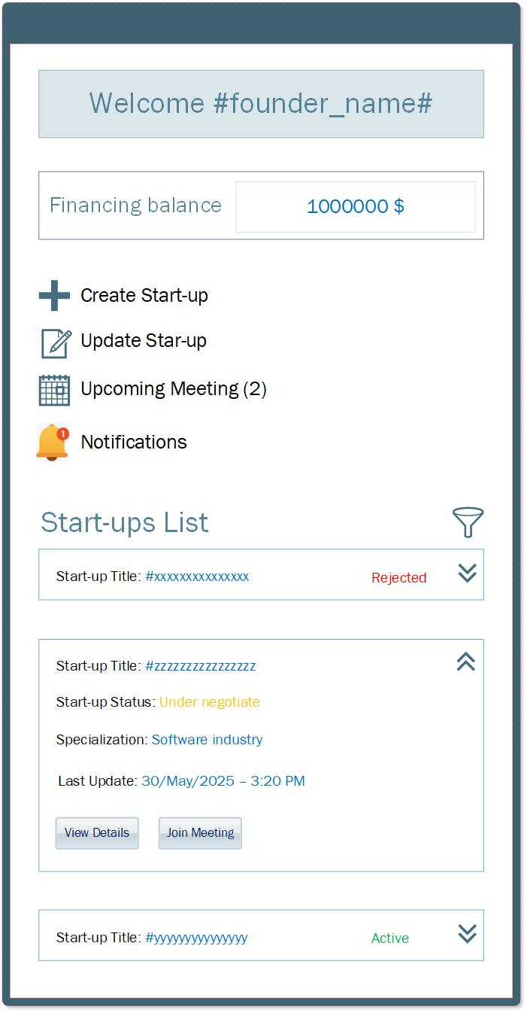
This screen is the Founder's landing page in the mobile application display a welcome message, financing balance amount and all start-ups status and allows the user to act the following actions:
Figure 1
- Create Start-up
- Edit rejected Start-up
- Filter start-ups
- View Star-up Cards
- View Star-up Details
- Join Meeting
- View Notifications

Investor Landing Page
This screen is the Founder's landing page in the mobile application display a welcome message, current investments balance and all start-ups stages and allows the user to act the following actions:
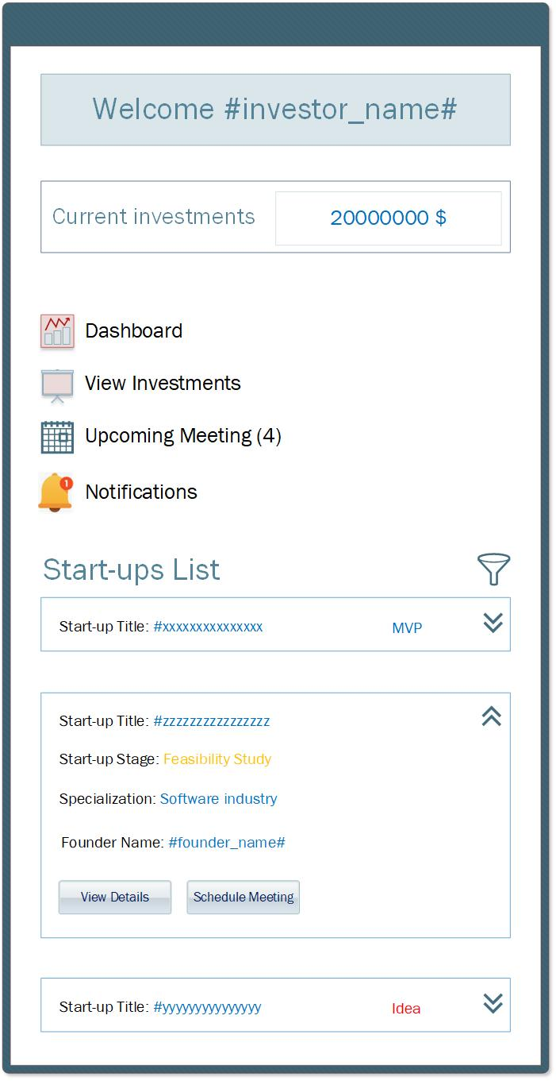
- View investments
Figure 2
- Filter start-ups
- View Star-up Cards
- View Star-up Details
- Schedule Meeting
- Join Meeting
- View Notifications
- View Dashboard

Admin Start-ups List

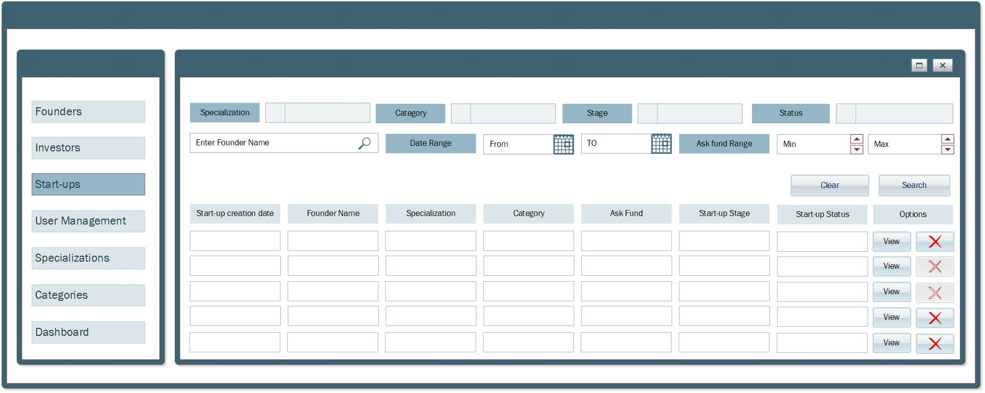
Figure 3

This screen is the start-ups list page in the admin web portal display all start-ups and allows the user to views the sidebar and act the following actions:
- Close screen
- Maximize screen
- View Star-up Details
- Delete start-up
- Search by:
  - Founder Name
  - Creation date range
  - Ask fund range
  - Start-up status
  - Start-up stage
  - Specialization
  - Category

